Table of Contents

1. Feature Specification Overview 2

1.1 Feature Description 2

2. Use Case: Change IBH 2

2.1 Feature Flow 2

2.2 Preconditions 2

2.3 Main Flow 2

3. Other feature Impacts 2

3.1 Item Modify 2

3.2 Transaction Modify 3

3.3 POSLog 3

3.4 Electronic Journal 3

3.5 Suspend/Resume Impacts 3

3.6 Training Mode Impacts 3

4. Screen Layouts 3

4.1 POS Screens 3

5. Printing 4

5.1 Receipt Changes 4

6. Configurable Settings 4

7. Out Of Scope 4

8. Business Sign Off 4

9. Revision History 4

9.1 Reviews 4

9.2 Revision History 4

Feature Specification Overview

## Feature Description

International Business Hierarchy (IBH) defines the location and business unit of a transaction. IBH contains 6 levels of definition. These levels are Enterprise, Trading Area, Company, Brand, Business Unit and Channel. Enterprise, Trading Area, Company and Brand remain the same for the store, however Business Unit and Channel can change based on device and/or transaction.

# Use Case: Change IBH

## Feature Flow



Figure : Process Flow

## Preconditions

* Transaction Started
* Change IBH Selected

## Main Flow

1. System prompts for IBH Reason Code (section 4.1.1).
2. If user selects Back, use case ends and system returns to calling use case.
3. If user selects a reason code and it was item IBH update, system updates the item IBH, use case ends and returns to calling use case.
4. If user selects a reason code and it was transaction IBH update, system updates the transasction IBH, use case ends and returns to calling use case.

# Other feature Impacts

## Item Modify

Item modify updated to add Change IBH to options and call Change IBH use case.

## Transaction Modify

Transaction modify updated to add Change IBH to options and call Change IBH use case.

## POSLog

POSLog updated to log IBH.

## Electronic Journal

Electronic Journal updated to indicate IBH changed.

## Suspend/Resume Impacts

All changes to IBH saved when transaction is suspended for use when resumed.

## Training Mode Impacts

Changing IBH is available during training mode.

# Screen Layouts

## POS Screens

### IBH Reason Codes

Displayed when Change IBH is selected for item or transaction.

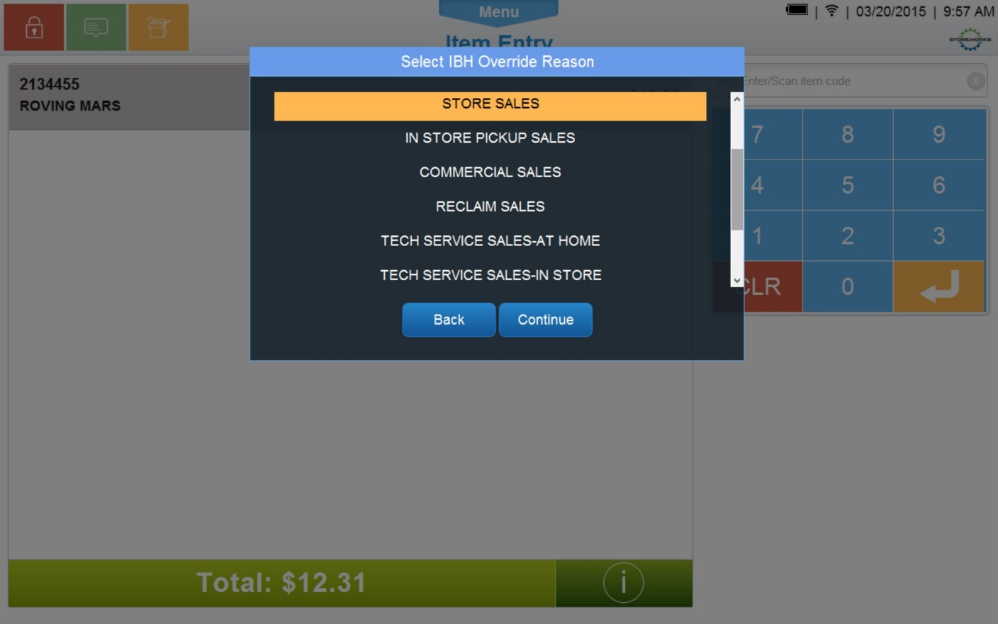

Figure : IBH Reason Code Screen

#### Screen Definitions

##### Title Text

|  |
| --- |
| **Instruction Text – Text Configurable** |
| Select IBH Override Reason |

##### Navigation/Menu Keys

|  |  |  |  |  |
| --- | --- | --- | --- | --- |
| **Key** | **Label** | **State** | **Next Screen** | **Notes** |
| Back | Back | Enabled | * Calling Use Case | Text is configurable |
| Continue | Continue | Enabled | * Updates IBH and returns to calling Use Case. | Text is configurable. |

##### Reason Code Enhancements

|  |  |  |
| --- | --- | --- |
| **Reason Code** | **Valid Values** | **Default Value** |
| IBH | * Text is configurable | First value defined in the list. |

# Printing

## Receipt Changes

No Receipt Changes for IBH.

# Configurable Settings

| **Parameter Mnemonic** | **Description** | **Valid Values** |
| --- | --- | --- |
| IBH Values | The IBH values for the device | IBH Values |

# Out Of Scope

* *This Document covers IBH Feature Functionality. Functionality that has no changes from the current processes is not covered unless needed to provide context.*

# Business Sign Off

|  |  |  |
| --- | --- | --- |
| **Name** | **Organization** | **Approval Email and/or Date Received** |
|  |  |  |

# Revision History

## Reviews

|  |  |  |
| --- | --- | --- |
| **Date** | **Iteration** | **Result** |
|  |  |  |

## Revision History

|  |  |  |  |
| --- | --- | --- | --- |
| **Reviser** | **Revision** | **Date** | **Version** |
| Amy Byers | Initial Document | 4/1/2015 | 1.0 |